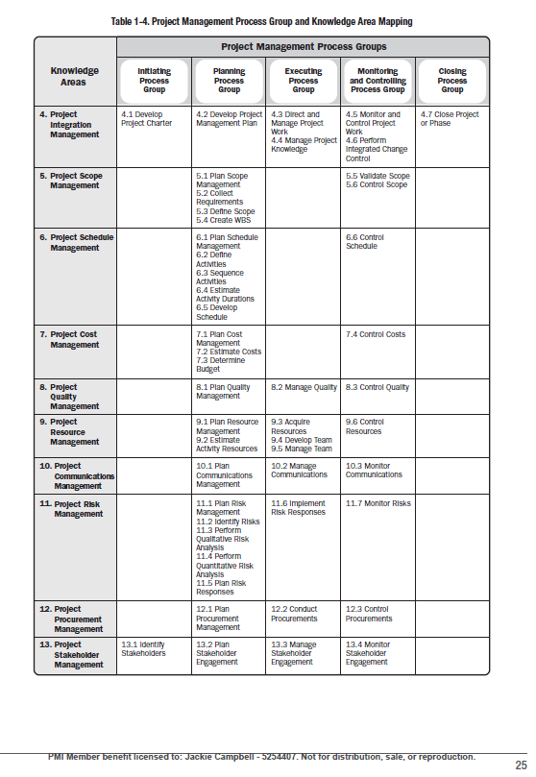

**Knowledge Groups**

**I Integration**

**S Scope**

**S Schedule**

**C Cost**

**Q Quality**

**R Resources**

**C Communication**

**R Risk**

**P Procurement**

**S Stakeholders**

|  |  |  |  |  |  |  |  |  |
| --- | --- | --- | --- | --- | --- | --- | --- | --- |
| **Initiating** | | **Planning** | **Executing** | | **Monitoring and**  **Controlling** | | **Closing** | |
| **Integration** | | | | | | | | |
|  | **Scope** | | |  | | **Scope** | |  |
|  | **Schedule** | | |  | | **Schedule** | |  |
|  | **Cost** | | |  | | **Cost** | |  |
|  | **Quality** | | | | | | |  |
|  | **Resources** | | | | | | |  |
|  | **Communication** | | | | | | |  |
|  | **Risk** | | | | | | |  |
|  | **Procurement** | | | | | | |  |
| **Stakeholder** | | | | | | | |  |